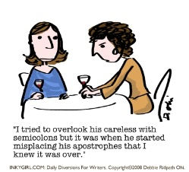
Quick Pre-Quiz on Apostrophes
Working only on your gut instincts, rewrite the following sentences with as many apostrophes as you think could be correctly inserted:
- The four spiders webs were not as intimidating as he had thought

- She did not believe that he would ever return to their houses fireside.

- He had not shown up since 1987. But if her mother said he would turn up in two weeks time, she would probably be right.

What do we use this pesky upside down comma for?
- To indicate a possessive in a singular noun, or, in layman’s terms, to say that one thing belongs to another. Give an example:

- To indicate time or quantity: Give an example.

- To indicate the omission of figures in dates. Give an example.

- To indicate the omission of letters: (Think Shakespeare) Give an example.

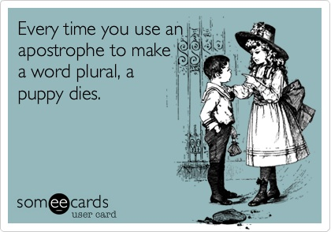

Fix the mistake(s):
- 

 