Some thoughts about sentENCes (none of them original)
What is a sentence? According to Urban Dictionary, a sentence is “1. A grammatical unit that is syntactically independent and has a subject that is expressed or, as in imperative sentences, understood and a predicate that contains at least one finite verb. “

According to the Oxford English Dictionary, a sentence is “A series of words in connected speech or writing, forming the grammatically complete expression of a single thought; in popular use often (= period n. 16), such a portion of a composition or utterance as extends from one full stop to another. In Grammar, the verbal expression of a proposition, question, command, or request, containing normally a subject and a predicate (though either of these may be omitted by ellipsis).

In grammatical use, though not in popular language, a ‘sentence’ may consist of a single word, as in Latin algeo ‘I am cold’, where the subject (= I) is expressed by the ending of the verb. English grammarians usually recognize three classes: simple sentences, complex sentences (which contain one or more subordinate clauses), and compound sentences (which have more than one subject or predicate).

You can diagram a sentence; some English teachers LOVE this:
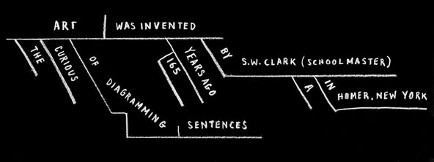

Here’s a tough one, from Henry James’s “The Golden Bowl”: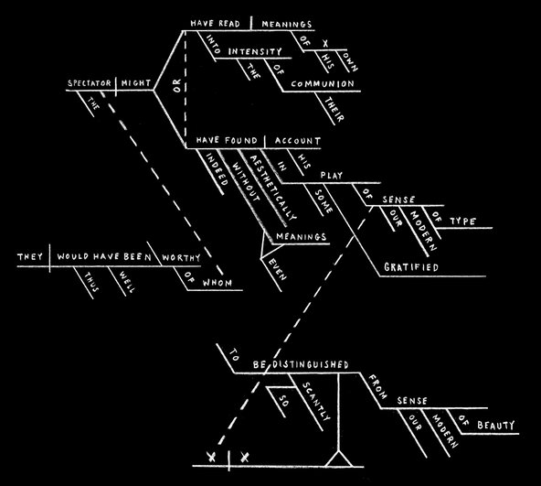
But these definitions “miss the essence of sentencehood. We are taught about the sentence from the outside in, about the punctuation first, rather than the essential components. The outline of our boat, the meaning of our every utterance, is given form by nouns and verbs. Nouns give us sentence subjects — our boat hulls. Verbs give us predicates — the forward momentum, the twists and turns, the abrupt stops.
For a sentence to be a sentence we need a What (the subject) and a So What (the predicate). The subject is the person, place, thing or idea we want to express something about; the predicate expresses the action, condition or effect of that subject. Think of the predicate as a predicament — the situation the subject is in.
I like to think of the whole sentence as a mini-narrative. It features a protagonist (the subject) and some sort of drama (the predicate):The searchlight sweeps. Harvey keeps on keeping on. The drama makes us pay attention” (Hale 2012).
Subjects in bold:
“They shoot the white girl first.” — Toni Morrison, “Paradise”
“Stately, plump Buck Mulligan came from the stairhead, bearing a bowl of lather on which a mirror and a razor lay crossed.” — James Joyce, “Ulysses”
“The Miss Lonelyhearts of the New York Post-Dispatch (Are-you-in-trouble? — Do-you-need-advice? — Write-to-Miss-Lonelyhearts-and-she-will-help-you) sat at his desk and stared at a piece of white cardboard.” — Nathanael West, “Miss Lonelyhearts”
Predicates in bold:
“Elmer Gantry was drunk.” — Sinclair Lewis, “Elmer Gantry”
“Every summer Lin Kong returned to Goose Village to divorce his wife, Shuyu.” — Ha Jin, “Waiting”
Variations:
“Call me Ishmael.” — Herman Melville, “Moby Dick”
“We started dying before the snow, and like the snow, we continued to fall.” — Louise Erdrich, “Tracks”
WILLIAM FAULKNER FAMOUSLY SAID that a novelist is a failed short story writer, and a short story writer is a failed poet. Hemingway, with his creation of the six-word story, combined poetry and drama into a short form that has grown in popularity while remaining difficult to achieve. Narrative is looking for six-word stories that can stand alongside the best that have been written. Here are a few:

For sale: Baby shoes. Never worn. —Ernest Hemingway
Longed for him. Got him. S***. —Margaret Atwood

Assignment: Spend five minutes chatting with the people in your group. Each individual begins a piece a paper with a 6 word sentence about themselves and passes it to the next person. That person writes a six word sentence about the person who started the paper (based on their interview or observation), pass it on. When everyone has written their sentences, the person being described will stand and introduce themselves using the 6 word sentences.

Homework: Take your 6 word sentences home and write a paragraph about yourself, incorporating as much of the information as possible into the paragraph. You may add or subtract. This paragraph will be typed, double spaced, following the format on the course expectations and submitted at the beginning of class Wed/Thurs along with the original 6 word sentences.

